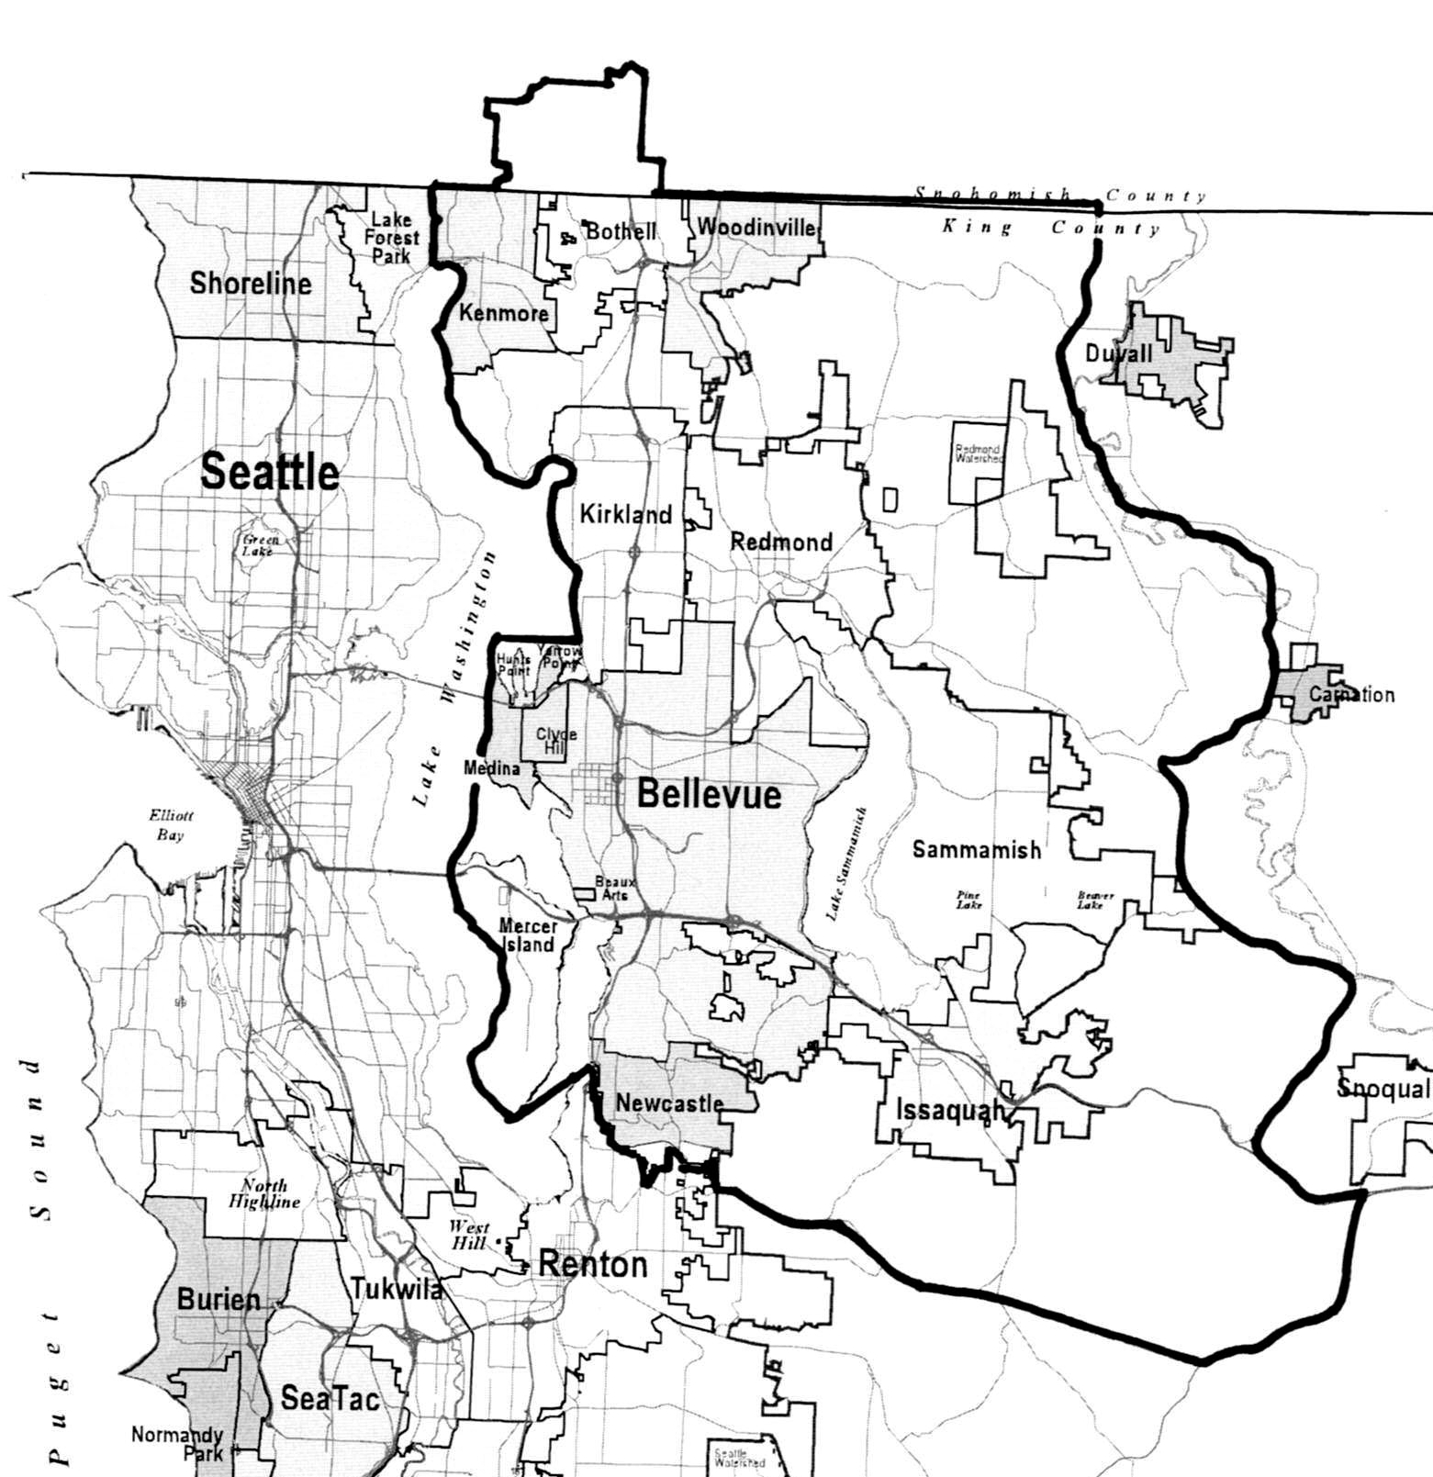
Bothell
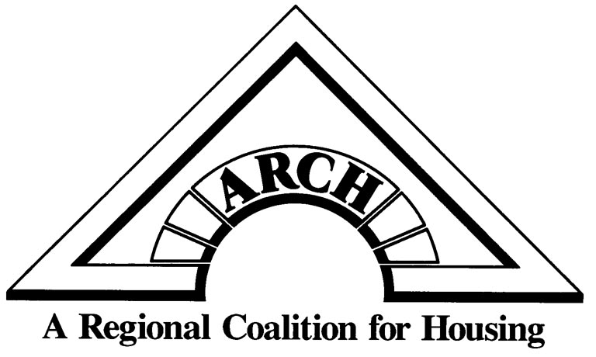
ARCH Sphere of Influence

ARCH Cities and surrounding
Unincorporated East King County area

BEAUX ARTS VILLAGE ♦ BELLEVUE ♦ BOTHELL ♦ CLYDE HILL ♦ HUNTS POINT ♦ ISSAQUAH ♦ KENMORE ♦ KIRKLAND
MEDINA ♦ MERCER ISLAND ♦ NEWCASTLE ♦ REDMOND ♦ SAMMAMISH ♦ WOODINVILLE ♦YARROW POINT ♦ KING COUNTY

